**Assignment no 22**

Program 1:

Code:

#include<stdio.h>

void main()

{

int arr[5]={12,23,34,4,67};

int* ptr;

ptr=arr;

int i;

for(i=0;i<5;i++)

{

printf("%d\t",*(ptr+i));

}

printf("\n");

for(i=0;i<5;i++)

{

printf("%d\t",*(arr+i));

}

}

Output:

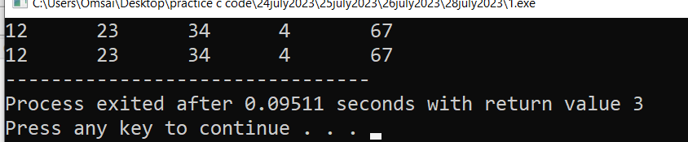

Program 2:

Code:

include<stdio.h>

void main()

{

int arr[5]={2,23};

int*ptr,i;

ptr=arr;

for(i=0;i<5;i++)

{

printf("%d\t",ptr[i]);

}

}

Output:

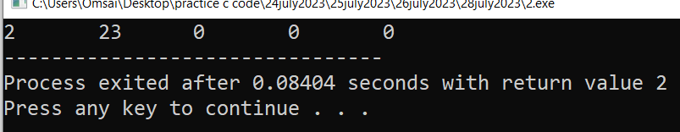

Program 3:

Code:

#include<stdio.h>

void main()

{

int arr[5];

int*ptr,i;

ptr=arr;

for(i=0;i<5;i++)

{

printf("enter the value:");

scanf("%d",&ptr[i]);

}

for(i=0;i<5;i++)

{

printf("%d\t",ptr[i]);

}

}

Output:

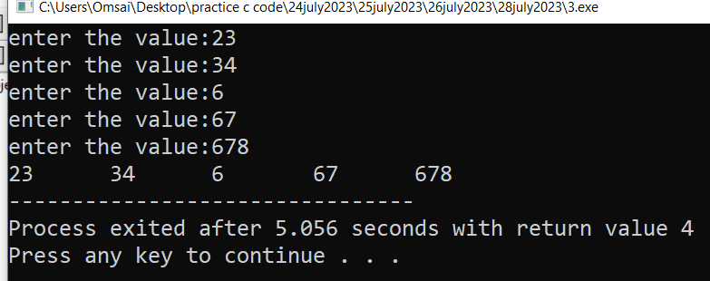

Program 4:

Code:

#include<stdio.h>

void display(int*,int);

void main()

{

int arr[5]={12,34};

int brr[3]={1,45,56};

display(arr,5);

display(arr,3);

}

void display(int*ptr,int t)

{

int i;

for(i=0;i<t;i++)

{

printf("%d\t",ptr[i]);

}

printf("\n");

}

output:

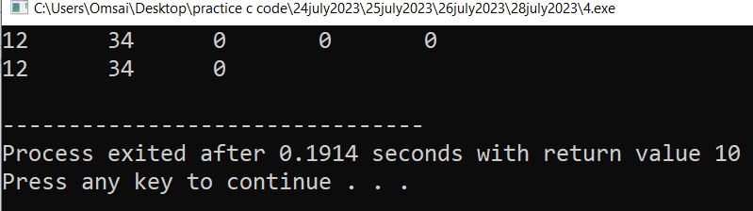

Program 5: find min no using function

Code:

#include<stdio.h>

void min(int*,int);

void main()

{

int arr[5]={12,345,6,35,57};

min(arr,5);

}

void min(int*ptr,int t)

{

int i,min=ptr[0];

for(i=0;i<t;i++)

{

if(min>ptr[i])

{

min=ptr[i];

}

}

printf("minimum element is :%d",min);

}

Output:

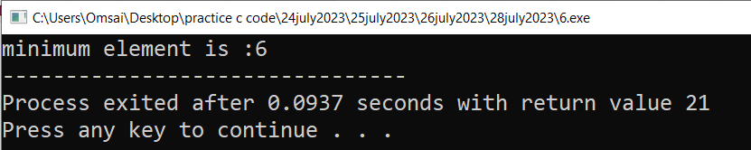

Program 6: find max using function

Code:

#include<stdio.h>

void max(int*,int);

void main()

{

int arr[5]={12,345,6,35,57};

max(arr,5);

}

void max(int*ptr,int t)

{

int i,max=ptr[0];

for(i=0;i<t;i++)

{

if(max<ptr[i])

{

max=ptr[i];

}

}

printf("maximum element is :%d",max);

}

Output:

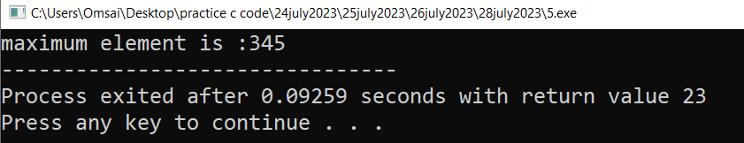

Program 7: sum of array element using function

Code:

#include<stdio.h>

void sum(int*,int);

void main()

{

int arr[5]={12,34,45,46,45};

sum(arr,5);

}

void sum(int*ptr,int t)

{

int i,sum=0;

for(i=0;i<t;i++)

{

sum=sum+ptr[i];

}

printf("sum:%d",sum);

}

Output:

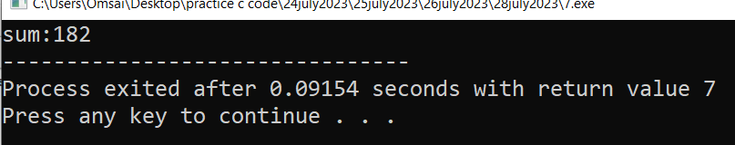

Program 8:find average using function in an array

Code:

#include<stdio.h>

void avg(int*,int);

void main()

{

int arr[5]={2,3,4,5,6};

avg(arr,5);

}

void avg(int*ptr,int t)

{

int i,sum=0;

float avg;

for(i=0;i<t;i++)

{

sum=sum+ptr[i];

}

avg=sum/t;

printf("Average:%f",avg);

}

Output:

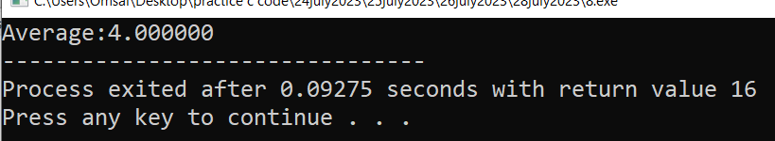

Program 9: search a number in an array using function

Code:

#include<stdio.h>

void search(int*,int,int);

void main()

{

int arr[5]={12,34,45,46,48};

search(arr,5,45);

}

void search(int*ptr,int t,int p)

{

int i;

for(i=0;i<t;i++)

{

if(p==ptr[i])

{

printf("%d is found",p);

}

}

}

Output:

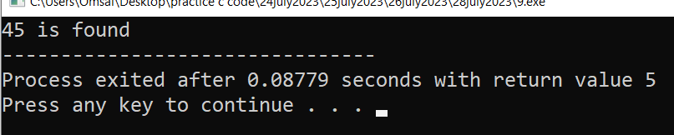

Program 10:find prime number in an array using function

Code:

#include<stdio.h>

void prime(int*,int);

void main()

{

int ar[5]={13,7,11,45,33};

prime(ar,5);

}

void prime(int*ar,int t)

{

int i,n,j,counter;

for(i=0;i<t;i++)

{

counter=0;

for(j=2;j<ar[i];j++)

{

if(ar[i]%j==0)

{

counter=1;

break;

}

}

if(counter==0)

{

printf("%d\t",ar[i]);

}

}

}

Output:

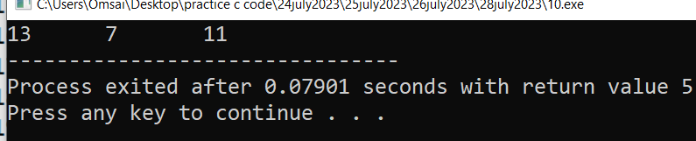

Program 11: find even number in an array using function

Code:

#include<stdio.h>

void even(int*,int);

void main()

{

int arr[5]={12,25,46,40,75};

even(arr,5);

}

void even(int*ptr,int t)

{

int i;

printf("even number:");

for(i=0;i<5;i++)

{

if(ptr[i]%2==0)

{

printf("%d\t",ptr[i]);

}

}

}

Output:

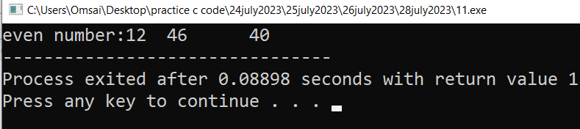

Program 12: find odd no in an array using function

Code:

#include<stdio.h>

void odd(int*,int);

void main()

{

int arr[5]={12,25,46,49,75};

odd(arr,5);

}

void odd(int*ptr,int t)

{

int i;

printf("odd number:");

for(i=0;i<5;i++)

{

if(ptr[i]%2==1)

{

printf("%d\t",ptr[i]);

}

}

}

Output:

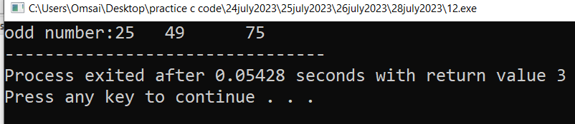

Program 13: write a program to copy all elements of one array into another array. using function in c

Code:

#include<stdio.h>

void copyarray(int*,int*,int);

void main()

{

int arr[5]={12,34};

int brr[5];

copyarray(brr,arr,5);

}

void copyarray(int*brr,int*arr,int t)

{

int i;

for(i=0;i<t;i++)

{

brr[i]=arr[i];

}

printf("element of brr:");

for(i=0;i<t;i++)

{

printf("%d\t",brr[i]);

}

}

Output:

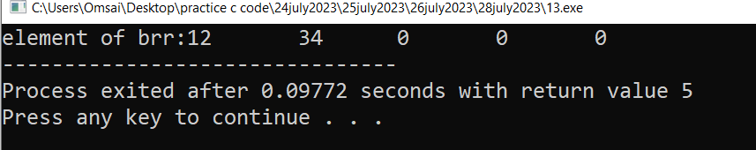

Program 14: write a program to accept the element of an array from the user and display the element using function

Code:

#include<stdio.h>

void display(int*,int);

void main()

{

int arr[5];

display(arr,5);

}

void display(int*arr,int t)

{

int i;

for(i=0;i<t;i++)

{

printf("enter the value:");

scanf("%d",&arr[i]);

}

for(i=0;i<t;i++)

{

printf("%d\t",arr[i]);

}

}

Output:

